P&G Health Neuroempathy

User Guide

# Setting Up

## AR

1. Go to webpage: <https://playcanv.as/p/df116420/>
   1. Allow camera and Bluetooth permission from browser prompt
2. Hardware setup TBC

## Non hardware

1. Go to webpage: <https://playcanv.as/p/dd2965bc/>
   1. Allow camera permission from browser prompt

# Hardware / software requirement

Browser

* Recommended Chrome Version 99.0.4844.84

Hardware

* Recommended models:
  + Huawei Nova 3i
  + iPhone 12 Pro Max
  + iPhone 11
  + // TODO replace with P&G device
* Android version 12 or iOS 15
* BLE version 2.1

Note: iOS version does not work with AR Bluetooth version

# Troubleshooting

## Web url broken (Subscription ended)

Check if subscription(<https://playcanvas.com/account>) is still active. Publishing is restricted to an active subscription.

## Site unreachable

Check if url/domain is blocked by your firewall. If so, please use mobile data instead of via intranet.

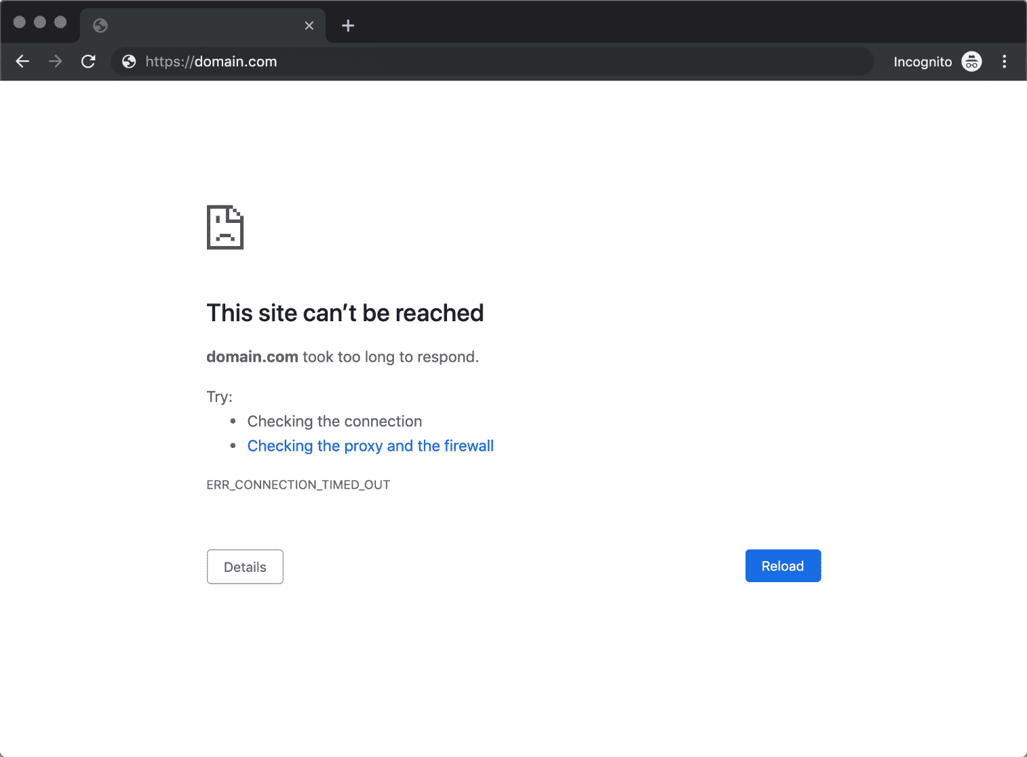

## Camera blocked

If camera was accidentally blocked, enable it again via settings.

Access settings for page via top right video permission icon.

Android & iOS (Chrome):

## Bluetooth pairing not found

After app is launched, program will request for pairing with glove’s Bluetooth. If device is not found, restart glove and restart app thereafter.

Android (Chrome):

## Blank screen due to WebView version incompatibility (Android)

How to update WebView:

Download and update Android System WebView from Google Play Store

<https://play.google.com/store/apps/details?id=com.google.android.webview&hl=en_AU&gl=US>